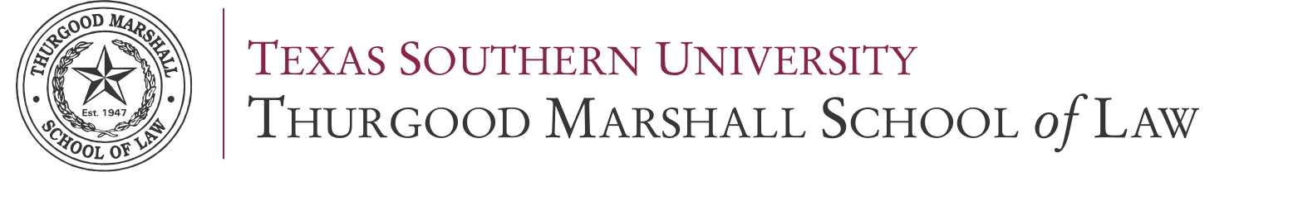
LAW 809
BAR ESSAY WRITING
Section 1
Fall 2017

ACADEMIC SUPPORT AND BAR READINESS

3100 CLEBURNE STREET | HOUSTON, TEXAS 77004
TELEPHONE: 713.313.1366 | FAX: 713.313.1049
TABLE OF CONTENTS
Course Books & Material ..............................................................................................................3 The Instructors ............................................................................................................................... 3
Course Description & Objective .................................................................................................... 4
Student Learning Outcomes ........................................................................................................... 5
Grading & Class Format ................................................................................................................ 5
Accommodations ........................................................................................................................... 7
Classroom Expectations ..................................................................................................................8
Academic Calendar ....................................................................................................................... 9
Reading Assignments...................................................................................................................... 9

COURSE BOOKS & MATERIAL

There is no required textbook for this course.

INSTRUCTOR* CONTACT INFORMATION

PLEASE DIRECT QUESTIONS ABOUT ASSIGNMENTS, GRADING OR COURSE CONTENT TO THE DEPARTMENT DEAN.
NAME: Ronda Harrison, Assistant Dean for Academic Support and Bar Readiness
TELEPHONE: 713-313-1366
EMAIL: magriggs@tmslaw.tsu.edu
OFFICE LOCATION: Room 241

ACADEMIC SUPPORT OFFICE HOURS:
 | Mon. | Tue. | Wed. | Thu. | Fri.
Ronda Harrison
Room 241
(713) 313-1366 roharrison@tmslaw.tsu.edu
Kevin Christiansen
Room 109
(832) 453-3786
kevinwadechristiansen@gmail.com
Room 108

*This course is taught by the Academic Support department faculty.

NOTE FROM THE DEAN:
This course is designed to help you develop the problem solving and analytical writing skills necessary for you to maximize your scores on the essay portion of the Texas Bar Examination. Formats presented in this course may be inconsistent with UBE jurisdictions.
BELOW ARE GENERAL ESSAY WRITING RECOMMENDATIONS FROM THE TEXAS BOARD OF LAW EXAMINERS
- Carefully read the question and the “call of the question,” (what the question asks you to do.)
- Pay attention to the facts presented without assuming additional facts.
- Include more than a mere conclusion when asked to explain the answer fully.
- Respond to the “call of the question” (what the question asks you to do) and stay on track.
- Practice writing in complete sentences and composing paragraphs.
- Organize your responses, and answer subparts, if any, in the order asked.
- Strive for clarity and good communication in writing.
- Avoid lengthy or unnecessary discussion of general or extraneous matters.
Texas examinees should read and be familiar with the Texas statutes and rules pertaining to the Texas essay and procedure and evidence exam-tested subjects. This is recommended regardless whether you have access to commercially-produced outlines or review materials.

http://www.ble.state.tx.us/exam_info/selected_answers/main_selected_answers.htm

COURSE DESCRIPTION & LEARNING OUTCOMES

COURSE DESCRIPTION:

This course will teach you how to answer the types of essay questions that will appear on the bar exam. It will show you what the rules frequently tested by the examiners and the essential components of a high scoring answer. You will gain experience writing answers to actual bar essay questions and you will receive personalized feedback on your essays with instruction on how to improve your writing.

This course is not intended as a substitute for a commercial bar review course. This course is designed for students preparing to sit for the Texas Bar Examination. Students should take this course during the semester immediately preceding law school graduation and bar study. Specific emphasis will be given to the frequently tested areas of the Texas Bar Exam.

COURSE OBJECTIVE:

The main objective of this course is to facilitate the development of competency required to pass the essay portion of the Texas Bar Exam.

STUDENT LEARNING OUTCOMES:
After completing this course with a passing grade, each student should be able to:

- understand the format of the Texas Essay Exam and the legal rules most frequently tested on the exam;

- construct essay answer templates by combining Texas statutes with previously tested subject matter; and

3 competently answer simulated exam questions under test conditions.

CLASS FORMAT & GRADING

In-class essay exams
During most class sessions, the instructor will administer an in-class essay. Students will have 30 minutes to complete the essay in class. We will provide or review any Code provisions or reading assignment prior to the in-class essay. All Texas statutes are available online at www.statutes.legis.state.tx.us. Normally, essays will be submitted using SoftTest (ExamSoft).

Grading matrix
 | # Offered | # Required | Max. Points Available
In-class essays | 12 | 10 | 100
Out-of-class essays | 12 | 10 | 100
Comprehensive Exam | 1 | 1 | 800
 |  |  | 1000 points

Grade scale
Grade | Cumulative Points
A | 800-1000
A- | 776-800
B+ | 751-775
B | 726-750
C+ | 701-725
C | 676-700
D | 0-675

The table above is only an estimation of final grade calculation.

Comprehensive exams
Students will take one comprehensive semester exam containing 6 essay questions.

ACCOMMODATIONS

If you require special accommodations, please fill out the necessary forms with the Dean's office. Your application and documentation will remain confidential. Your prompt attention will allow the law school to accommodate you, as soon as it has been made aware of your situation.

Please see:
http://www.tsulaw.edu/student_affairs/docs/2011-2012AccommodationsHandbook.pdf

CLASSROOM EXPECTATIONS

ATTENDANCE
See Students’ Rules of Matriculation for details on absences and grade reductions.

CLASS ETIQUETTE
- Mobile and cellular phones must be powered off or fully silent during class times. (No vibrations, alarms, text or message signals, or flashing lights).
- Please do not eat breakfast, lunch or heavy snacks in the classroom during class time. Food, gum and snacks may create an unwelcome smell and noise distraction during exams and lessons.
- Please refrain from coming to class late or departing during class instruction. It is disruptive, and disrespectful to your instructor and classmates.
- Permissible laptop usage is limited to writing and submitting essays.
- When e-mailing your professor, be appropriate and professional in your communication. Begin the e-mail with a greeting and address me by title and surname. Use a subject line that clearly denotes the purpose/topic of your message. Close the message with your full name and contact information. Do not "reply" to a message sent from your instructor with an unrelated topic without first changing the subject line. I reserve the right to ignore non-compliant messages.

ACADEMIC CALENDAR

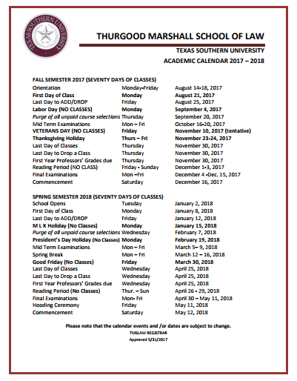

SYLLABUS
Class period | In Class Assignment | Assignment to be completed before next class
Week 1  January 8-12 | Introduction to the course  IRAC essay formatting | Review Guardianships
Week 2  January 15-19 | Guardianship Lecture  In-class Guardianship Essay | Complete out-of-class Guardianship Essay  Review Family Law/SAPCR
Week 3  January 22-26 | Family Law/SAPCR Lecture  In-class SAPCR Essay | Complete out-of-class SAPCR Essay  Review Community Property
Week 4  January 29-February 2 | Community Property Lecture  In-class Community Property Essay | Complete out-of-class Community Property Essay  Review Intestacy
Week 5  February 5- 9 | Intestacy Lecture  In-class Intestacy Essay | Complete out-of-class Intestacy Essay  Review Wills
Week 6  February 12-16 | Wills Lecture  In-class Wills Essay | Complete out-of-class Wills Essay  Review Trusts
Week 7  February 19-23 | Trusts Lecture  In-class Trusts Essay | Complete out-of-class Trusts Essay
Week 8  February 26- March 2 | Review | Review Partnerships
Week 9  March 5- 9 | Partnerships Lecture  In-class Partnerships Essay | Complete out-of-class Partnerships Essay  Review Corporations
Week 10  March 12-16 | Corporations Lecture  In-class Corporations Essay | Complete out-of-class Corporations Essay  Review Commercial Paper
Week 11  March 19-23 | Commercial Paper Lecture  In-class Commercial Paper Essay | Complete out-of-class Commercial Paper Essay  Review Secured Transactions
Week 12  March 26-30 | Secured Transactions Lecture  In-class Secured Transactions Essay | Complete out-of-class Secured Transactions Essay  Review Oil and Gas
Week 13  April 2-6 | Oil and Gas Lecture  In-class Oil and Gas Essay | Complete out-of-class Oil and Gas Essay  Review Consumer Law
Week 14  April 9-13 | Consumer Law Lecture  In-class Consumer Law Essay | Complete out-of-class Consumer Law Outline
Week 15  April 16-20 | Review Essay Formatting and Substantive Law Review | Essay Assignment Due May 9, 2018
Week 16  Finals | Comprehensive Exam (6 Essay Questions)
|

