Seminar In Taxation
LAW 805
Fall 2019

Adjunct Profesor Shelia Dansby Harvey

The Professor
Name: Shelia Dansby Harvey
Meeting Times: Mondays and Wednesdays, 10:30 - 11:45
Meeting Room: 212
Telephone: 281.381.0196
Office Hours: Mondays and Wednesdays
Noon - 1 p.m.
(All other times by appointment only)

Course Books & Material
Required Reading: Leonard E. Burman and Joel Slemrod, Taxes In America:What Everyone Needs To Know (2013).

Suggested Reading: Elizabeth Fajans and Mary R. Falk, Scholarly Writing for Law Students (5th ed 2017)

Additional readings will be assigned periodically.

Course Description & Objective

Course Description:

Taxation academics are fond of quoting Justice Oliver Wendell Holmes who once said, “Taxes are what we pay for civilized society.” This seminar focuses on the role of federal tax policy in promoting and discouraging behavior deemed beneficial or detrimental to maintaining our democracy. The Internal Revenue Code includes dozens of provisions that arguably employ tax policy to shape and prioritize social outcomes. For almost every provision, questions abound, including: who should pay the taxes? Is taxation the correct vehicle for molding behavior? Is the provision effective? Should there be an expansion or contraction of the provision or the policy goal, and if so, what would that look like? This seminar will explore selected tax policy provisions.
Objective:

The primary seminar goal is to assist students in developing scholarly writing skills grounded in critical thinking, in-depth research and the ability to add to (rather than rehash) the academic conversation. The secondary objective is to expose students to the broader implications of selected Internal Revenue Code provisions.

Student Learning Outcomes

Student Outcomes--  By the end of this course a student will be able to: | Evaluation Tool--  In furtherance of these outcomes, a student will be required to:
- Identify and assert issues impacting tax policy  - Develop and support a legal position based on the identified issue  - Practice persuasive argument writing styles in a comprehensively researched paper | - Prepare a thesis statement.  - Prepare a draft outline  - Defend thesis statement in  presentation style format  - Prepare first and second  δrafts of researched thesis  - Πresent researched drafts  - Use skills to prepare a final  χomprehensive academic paper

Grading
Participation/Attendance 10 points
Research Paper Drafts 40 points
Final Research Paper 50 points
100 points
Writing Requirement Guidelines
This seminar meets the Writing Requirement for graduation. Students are expected to meet all deadlines stated in this syllabus.

Students may select a topic from the list below or propose a different topic. Students must select their topics and have them approved by the professor no later than Wednesday, September 4, 2019. Please notify the professor of your topic by sending an email to shelia@SheliaDansbyHarvey.com. Because some of the topics might be similar, the selection statement should include a brief description of the topic. Generally, topics will be approved in the order they are submitted. Topic cannot be changed without the professor’s permission.

Please adhere to the following guidelines.

Thesis Presentation: Each student should offer a topic that states a position they will prove. Students prepare 5 minute presentations on the law and their proposed position. The position is expected to be based on initial stages of research. Students must select topics that can be sufficiently developed.

Persuasive Argument Presentation: The outlines students submit prior to this presentation should be thoroughly researched and contain numerous legal sources comprised of cases, statutes, legislative history, and law review articles. The presentations should be about 10 minutes each.

Excerpts on Topics: Students’ progress from thesis to second draft should be evident in this 10 minute presentation.
Students are expected to use PowerPoint as an aid to their Persuasive Argument and Excerpts on Topics presentations.

- Capital gains tax
- Charitable contributions deduction
- Child subsidies (CTC, CDCTC)
- Community development tax incentives (e.g., NMTC, EZs, LIHTC)
- Education tax incentives
- Estate tax and inheritance tax
- Executive Compensation
- Expensing and depreciation
- Health insurance tax subsidies (ACA subsidies, ESI exclusion, HSAs and HDHPs)
- Mortgage interest deduction/homeownership tax incentives
- Research and experimentation tax credit/taxes and innovation
- Retirement tax incentives (IRAs, 401(k) plans, pensions)
- “Sin Taxes”
- State and local tax deduction
- Subsidizing work (EITC, WOTC, WWOTC)
- Taxes and small business
- Taxation of multinationals
- Tax-exempt bonds

Accommodations

Students requesting accommodations may do so through the Office of Student Affairs.

Participation, Attendance & Professionalism

Students are expected to be fully engaged in classes and behave professionally at all times. Participation includes being prepared to discuss assigned reading and tasks. Professionalism includes showing interest in presentations given by the professor, fellow students and guest speakers. Students are required to focus on activities taking place in the classroom and set aside all distractions, including side conversations, cell phones and laptops. Students should readily share their research challenges and progress with the class. Most importantly, students’ behavior should show that they embrace the opportunity to add to the scholarly discussion regarding their chosen topics.

Class attendance is required and only 3 absences are allowed. This class will take roll by signature. Failure to sign the attendance sheet will be considered an absence.

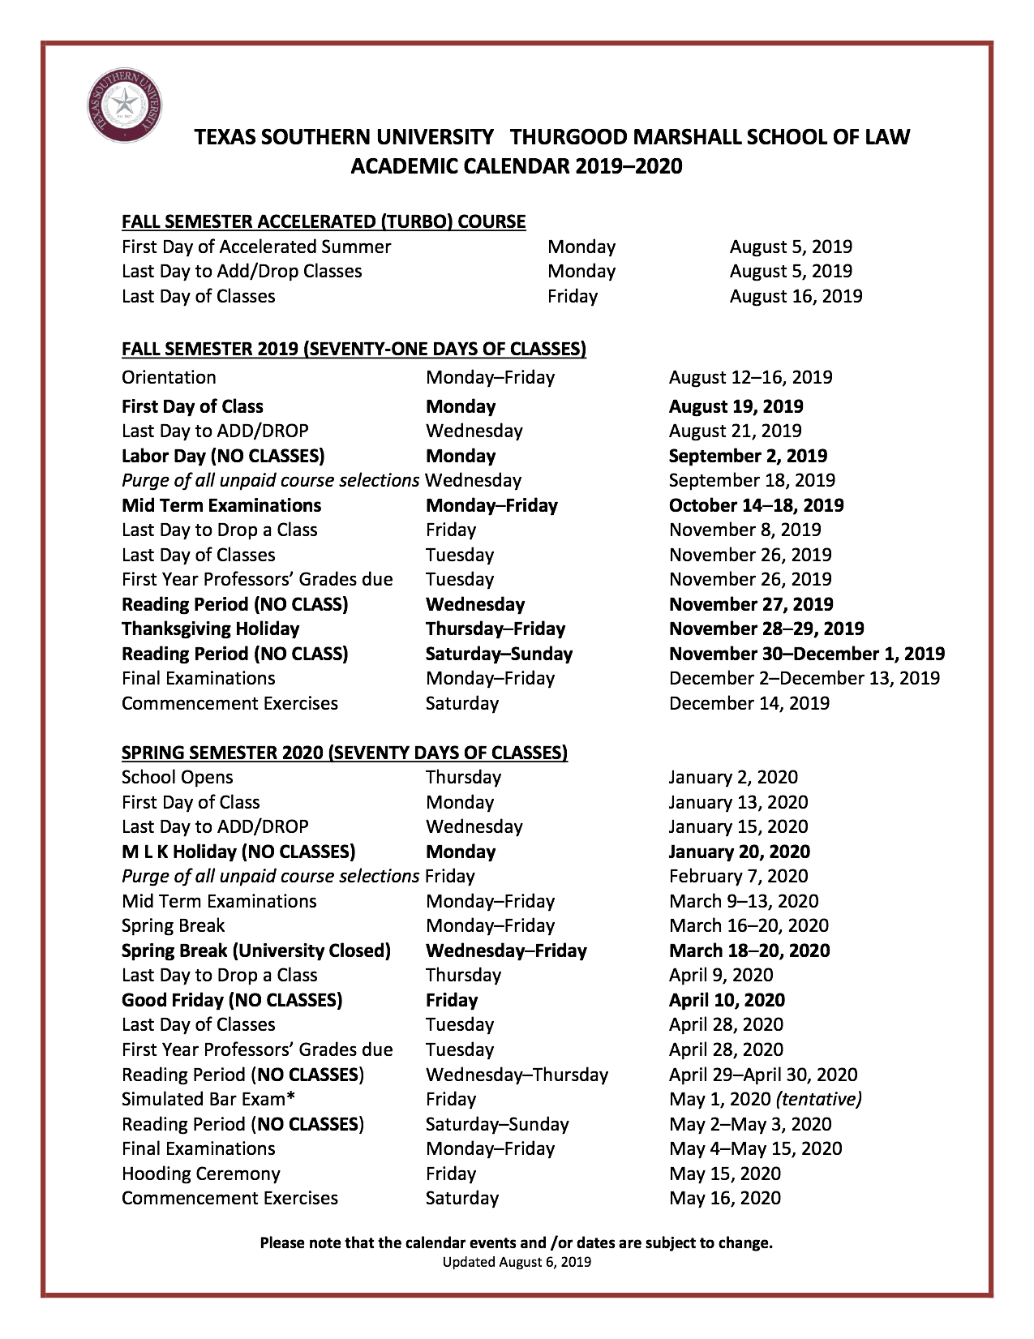
Academic Calendar

Policies & Procedures

Appendix A
ASSIGNMENTS

AUG 19 INTRODUCTION
AUG 21 WHAT IS TAX POLICY?
AUG 26 TOPIC & THESIS
AUG 28 TAX POLICY CURRENT HOT TOPICS

SEPT 4 HOT TOPICS, cont. (Last day to submit selected topic)
SEPT 9 THESIS PRESENTATION (first 1/2 of class in alphabetical order)
SEPT 11 THESIS PRESENTATION (second 1/2 of class)
SEPT 16 RESEARCH DISCUSSION
SEPT 18 TAX INEQUALITY
SEPT 23 PERSUASIVE ARGUMENTS
SEPT 25 PERSUASIVE ARGUMENTS
SEPT 30 PERSUASIVE ARGUMENTS

OCT 2 PERSUASIVE ARGUMENTS
OCT 7 PERSUASIVE ARGUMENTS
OCT 9 PEER EXCHANGE & REVIEW
OCT 14 NO CLASS
OCT 16 FIRST DRAFT DUE BY 11 AM
OCT 21 EXCERPTS ON TOPICS
OCT 23 EXCERPTS ON TOPICS
OCT 28 EXCERPTS ON TOPICS
OCT 30 EXCERPTS ON TOPICS

NOV 4 EDITING
NOV 6 GUEST SPEAKER
NOV 11 SECOND DRAFT DUE BY 11 AM
NOV 18 HOT TOPICS REVISITED
NOV 20 EDITING
NOV 25 LAST DAY OF CLASS — WRAP-UP

DEC 6 FINAL PAPER DUE BY 11 AM

FINAL PAPER DUE BY NOON

Appendix B
GUIDANCE for WRITING REQUIREMENT PAPER
Students must complete first drafts of their paper that must include the following:
- cover sheet
- table of contents
- single-spaced footnotes with proper Bluebook format
- table of authorities
- 12-point font (Times Roman), one-inch margins (on top, bottom, left and right)
- minimum 15 pages. Page “1”
Part 1. Introduction: Your thesis statement; Explain why the topic is an important problem or issue in law; identify the positions taken by other scholars in the area;
Part 2. Discussion of the legislative or judicial history on your issue;
Part 3. Discussion of statutes, cases, and law review articles where you have
Part 4. Your original contribution to the academic conversation.
Second drafts include all the first draft requirements and be at least 20 pages. The second draft should show an improved level of critical examination.
Students’ final submissions should reflect the a high-quality level of critical thinking and scholarly writing.

Appendix C
(Taken from the Student Rules and Regulations, Part B. Seminars and Independent Research)
1. Seminars
Seminars are offerings normally restricted to 16 students or, at the instructor’s option, 20 students, in which the instructor must require rigorous written work, which comprises at least two-thirds of the basis for the grade.
The Law School's Requirements for a Seminar Paper
At present, students must take a seminar offering "in which the instructor must require rigorous written work, which comprises at least two-thirds of the basis for the grade." (See Student Rules and Regulations 2008-2009, page 8.) The seminars that fulfill this requirement are so marked in the law school's offerings.
Neither a clinic nor a simulation course may substitute for the seminar requirement, but credit for an independent research project in lieu of a seminar is possible when the project "is equivalent in scope in quality to a seminar paper" and a copy of the student's paper is filed with the Office of the Dean. (See Student Rules and Regulations 2008-2009, page 8.)
At present, there is a registration procedure for both LAW 802 Independent Research I and LAW 803 Independent Research II. Also, the paper written for both courses "must be equivalent in scope to a Law Review article of at least 20 double spaced typewritten pages, excluding the cover, table of contents, footnotes, and Table of Authorities." In addition to an application, students must 9 submit "an exhaustive outline for the paper." Scholarly Writing for Law Students is a required text. And, students must meet at least monthly with the supervising professor. (For LAW 802, see Spring 09 Guidelines, page 1, 2, 4, and 6-7.)

We believe that the "rigorous written work" required for a Seminar Paper should at least meet the minimum requirements set out for an independent research project. We have completed extensive research of other law schools that have a similar requirement, and we plan to make this information available in a series of Quick Teaching Tips. We have also compiled a set of resources to help the faculty and students, and we will make these resources available to faculty through a series of Quick Teaching Tips and to students through our Learning & Assessment Lab.
Based on the educational literature, a student's Seminar Paper should show the student's mastery of the in-depth research undertaken and demonstrate how the student has organized, clarified, or advanced this body of knowledge in resolving the issues raised by the paper. The qualities that make a Seminar Paper different from many other law school writing projects are:
1. Original Analysis,
2. Comprehensive Research on the Topic, and Extensive Footnotes.
Twenty double-spaced typewritten pages, excluding the cover, table of contents, footnotes, and Table of Authorities, is a minimum requirement for a seminar paper as is 12-point font (Times Roman), one-inch margins (on top, bottom, left and right), and single-spaced footnotes that follow the Blue Book for citations. Because our students need to be introduced to the process of scholarly writing and because we have found assessment to be essential to our student's mastering skills, we propose the following steps as minimum requirements for a seminar paper:
- Students select a topic that the meets the professor's requirement for the seminar.
- Students submit an initial, brief description of the topic and a research plan under the guidance of the
professor; students meet with the professor to discuss progress on the seminar paper to be sure that the student is on the right track and, if necessary, students are directed to scholarly writing resources in the Learning & Assessment Lab.

- Students conduct research and develop a detailed outline, annotated with references to the key cases and other materials that the student plans to consider under the guidance of the professor; students meet with the professor to discuss progress on the seminar paper to be sure that the student is on the right track and, if necessary, students are directed to scholarly writing resources in the Learning & Assessment Lab.
- Students submit drafts of the seminar paper and receive feedback; students meet with the professor to discuss progress on the seminar paper to be sure 10 that the student is on the right track and, if necessary, students are directed to scholarly writing resources in the Learning & Assessment Lab.
- Students submit a final paper that is at least 20 double-spaced typewritten pages, excluding the cover, table of contents, footnotes, and Table of Authorities etc., with 12-point font (Times Roman), one-inch margins (on top, bottom, left and right), and single-spaced footnotes that follow the Blue Book for citations; students meet with professor to discuss the final paper.
- A copy of the student's submissions with faculty feedback is submitted to our data base for works in progress.

The list of proposed research topics includes numerous topics suggested by Leonard E. Burman for his course, Tax Politics & Policy, Syracuse University, Spring 2018.

