evidence
LAW 600 / SECTION 4
M/W/F 4-450, Room 212
FALL 2017

PROFESSOR SPEARIT

Table of Contents
The Professor 3
Course Books & Material 4
Course Description & Objective 5
Student Learning Outcomes 6
Grading 7
Accommodations 8
Participation, Attendance & Professionalism 9
Academic Calendar 10
Policies & Procedures 11
Reading Assignments 12

The Professor

Name: SpearIt
Telephone: 713-313-7276
Email: spearit@tmslaw.tsu.edu
Location: Suite 236N
Office Hours: M/W 1-4 and by appointment

Note on office hours:
Please note—aside from regular office hours I maintain an “open door” policy by which you can stop by my office anytime my door is open/cracked. If my door is completely shut, it means that I am preparing for class or working on school-related business—so unless it is an emergency, please stop by at another time or schedule a time to meet.

Course Books & Material

1.) Cases & Materials on the Rules of Evidence, 7th edition, Olin Guy Wellborn.
2.) Federal Rules of Evidence: With Advisory Committee Notes and Legislative History (2016), Christopher B. Mueller & Laird C. Kirkpatrick. If you do not wish to purchase the recommended text, you may use a 2013 edition of the FRE or later, but it must have the comments to the rules. Be prepared to show that you have access to the casebook, rules and comments for class participation. You will be asked to leave the room and will be marked absent if you are not prepared with these materials.

Course Description & Objective

Description:
This course will provide a thorough overview of the Federal Rules of Evidence (FRE) along with distinctions with the common law of evidence. The FRE determine whether evidence will be admitted or excluded from a federal trial, which is applicable both in civil and criminal litigation settings. Many state evidence rules, including the Texas rules, mirror the FRE, and so students wishing to litigate in either area have a stake in careful study of the rules.

This course concentrates on the main rules and concepts that students are likely to encounter, both on the bar examination as well as in practice. Evidence is one of the most highly tested subjects on bar examinations, and so when possible, the course will include discussions of how evidence law interacts with other areas of law, including professional responsibility and criminal procedure. Topics include relevance, hearsay, witnesses, opinions and expert testimony, confrontation, and authentication and identification among other evidentiary concepts, standards, and procedures.

Objective:
The primary focus of the course is to understand the FRE in practical context. The FRE can be best understood when analyzed and applied in problem-based approaches, and so students will be exposed to variations of a rule’s applicability and see how a rule works in tandem with other rules.

A secondary course focus is to hone student test-taking skills. As evidence is a subject of the Texas Bar Examination, students will develop better exam strategies and will be afforded the opportunity to develop their skills by practicing on bar style examination questions with ongoing feedback from the instructor.

Finally, students will focus on developing practical writing skills by drafting a motion in limine and memorandum in support. This simulation exercise will ground students in an important evidentiary aspect of litigation, while considering the strategies behind such a motion.

Student Learning Outcomes

After reading course materials, briefing cases, and participating in class discussions, by the end of the semester, students will be able to analyze the facts of a case and determine the evidentiary issues at stake. The student will also be able to evaluate the facts to determine whether, according to the FRE, a particular piece of evidence should be excluded or admitted at trial, as well as articulate policy rationales for the outcome. Furthermore, students will become competent in identifying paradigmatic question structures on multiple-choice questions and will master 30-minute essay style exam questions. Finally, students will develop legal document drafting and argumentation skills.

Grading

30% Final Exam
30% Midterm Exam
30% Motion Drafting Assignment (First Draft due by 10/9; Final by 11/29)
10% Evidentiary Hearing Assignment (1-page hardcopy due by 11/29)

Accommodations

If you require special accommodations, please fill out the necessary forms with the Dean's office. Your application and documentation will remain confidential. Your prompt attention will allow the law school to accommodate you, as soon as it has been made aware of your situation.

Also, please contact Dean Mouton (Student Affairs) if you require any special accommodations regarding any of the assignments, including but not limited to, extensions, note-takers, etc. You must contact Dean Mouton before the related assignment is due.

Please see:
http://tmsl.tsu.edu/student_affairs/docs/accomodations-handbook.pdf

Participation, Attendance & Professionalism

- Attendance is mandatory; school of law policy, informed by the ABA accreditation standards, requires regular and punctual attendance. Excessive absences will likely affect your grade and you may be dropped from the course.
- For every class, a student must have immediate access to the casebook and the FRE with commentary. Coming to class without these materials should be viewed as unprofessional, and will affect one’s class participation grade and attendance. Any student not having these hardcopy materials will be asked to leave the class.
- You will need access to TSU Blackboard and ExamSoft/Softest. I will be posting assignments and communicating with you on Blackboard and we will be using ExamSoft for assessments.
- The class should be treated as a court session and should be approached with utmost professionalism. Please handle restroom breaks, phone calls, and other business before class. Should you choose to disrupt the class by repeat tardy appearances or by leaving the classroom during class, you should be prepared to articulate your conduct.
- Students may prepare an outline that may be used on the midterm/final (25/50 page limit). The outline must be prepared by each student individually.
- No texts other than the casebook & rules are allowed in the classroom. Students are encouraged to supplement these materials with outside materials.
- No electronics during classtime; no cell phones, tablets, computers or other devices are allowed during instruction.
- Outstanding class participation will raise your grade by a mark; repeated inability to participate or unpreparedness in class will lower your grade by the same.
- To enhance the learning experience you will have opportunity to learn through class participation and rigorous questioning. Students should read all material assigned for a class and be fully prepared for class discussion. Students will be called on daily from the class roster. If you are not able to participate effectively, please be prepared to do so by next class meeting.
- Evidentiary Hearing Assignment: students will view a direct and cross examination of a witness and write a one-page reflection paper discussing relevant issues that have been discussed in the course. For this assignment you can comment on the proceedings, cite rules, or any objections you would have made as opposing counsel in addition to the judge’s rulings on objections. The video can be found at: https://www.youtube.com/watch?v=LDRxeqVowzk. Start at 3:06:06, the direct examination of Ian Freeman, until the end.

Academic Calendar
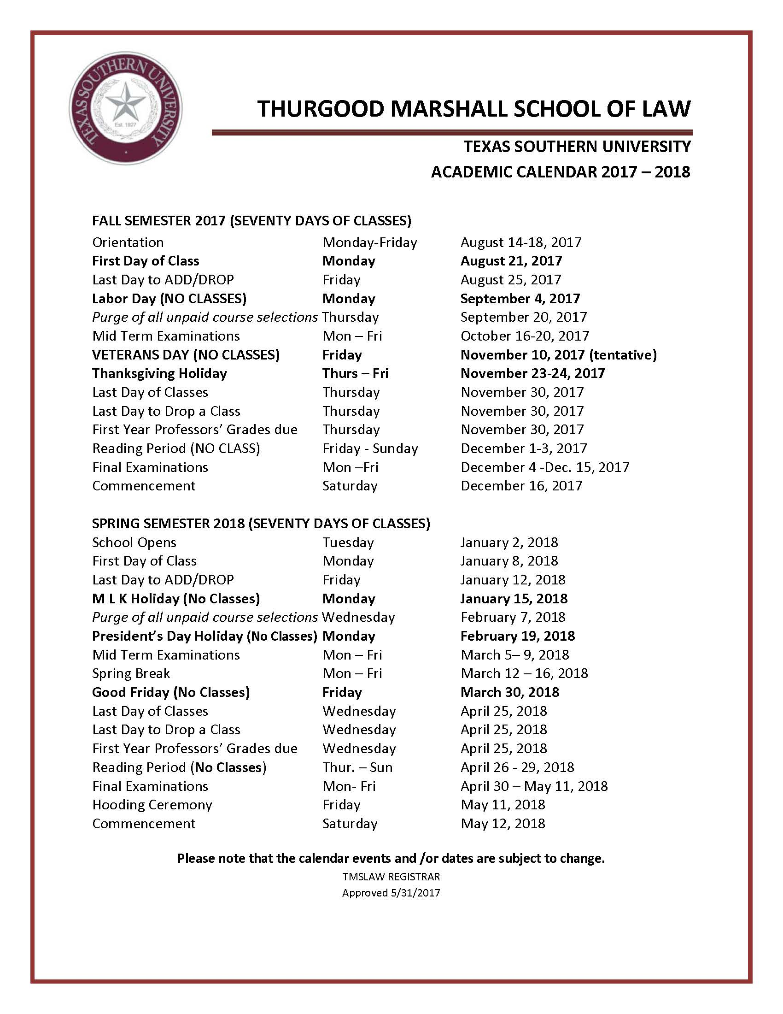

Policies & Procedures
Please reference the Thurgood Marshall School of Law 2016-2017 Rules and Regulations:
http://www.tsulaw.edu/student_affairs/docs/2016-2017_Rules_Regulations.pdf.

Reading Assignments

Week 1
RELEVANCE
8/21 Intro to the Course, Relevancy, (1-17)

8/23 Relevancy & Character, (17-38)

8/25 Relevancy & Other Crimes, Wrongs, (41-55)

Week 2
8/28 Relevancy & Other Crimes, Sex Crimes, Similar Prior Sexual Experience & Acts of Victim, (56-69)

8/30 Relevancy of Character & Similar Prior Sexual Experience, Civil Cases, Habit, (69-88)

9/1 Remedial Measures, Compromise, Liability Insurance, (88-107)

Week 3
HEARSAY

9/4 Holiday (No Classes)

9/6 Intro to Hearsay, Verbal Acts, Effect on State of Mind, Implied Assertions, (109-24)

9/8 Hearsay, Implied Assertions, In/consistent Statements, (125-136)

Week 4
9/11 Identification of a Person, Admissions, Adoptive Statements, (137-54)

9/13 Authorized, Agent/Servant, Coconspirator, (154-69)

9/15 Present Sense Impression, Excited Utterance, Then Existing Physical Condition,
State of Mind, (169-80)

Week 5
9/18 State of Mind, Medical Diagnosis/Treatment, (180-202)

9/20 Recorded Recollection, Records of Regular Conduct, (206-229)

9/22 Public Records & Reports, Learned Treatises, Former Testimony, (221-236)

Week 6
9/25 Impending Death, Statement Against Interest, (236-242)

9/27 Criminal Cases, Offered by the Prosecution/Accused, (243-258)

9/29 Forfeiture by Wrongdoing, Residual Exception, Confrontation, (258-281)

Week 7
10/2 Confrontation (281-304)

PROCEDURES FOR ADMITTING/EXCLUDING EVIDENCE
10/4 Timeliness, Specificity, Offers of Proof, (305-317)

10/6 Preliminary Questions, Limited Admissibility, Remainder of Writings/Recorded Statements, Opening the Door, (317-28)

Week 8
WITNESSES
10/9 MIL Due by Midnight / Competency, Children, Dead Man’s Statutes, (329-37)

10/11 Lack of Personal Knowledge, Competency of Juror, Impeachment, (337-344)

10/13 Prior Inconsistent Statements, Bias or Interest, Character for Truth, (344-58)

Week 9
10/16 Character for Truth, Other Misconduct, Reputation/Opinion for Character, (358-71)

10/18 MIDTERM REVIEW

10/20 MIDTERM EXAM—(covering classes and chaps 1&2)

Week 10
10/23 Reputation/Opinion Evidence for Truthfulness, Capacity, (371-80)

10/25 Contradiction, Impeaching One’s Own Witness, Control by Court, (381-90)

10/27 Protecting Child Victim Witnesses, Scope of Cross-Examination, (390-99)

Week 11
10/30 Leading Questions, Writing Used to Refresh Memory, Exclusion of witness, (400-416)

OPINION AND EXPERT TESTIMONY

11/1 Testimony by Lay Witnesses, Testimony by Experts, (417-430)

11/3 SKIM—Reliability, Relevancy, Gatekeeping, (430-59)

Week 12

11/6 Authentication & Identification, Writings, Voices & Telephone Conversations, Photographic Evidence, Demonstrative (Illustrative) Evidence, (475-90)

11/8 Writings, Originals/Duplicates, Admissibility of Other Evidence of Contents Public Records (491-507)

11/10 Holiday—no class

Week 13
11/13 Summaries, Testimony or Written Admission of Party, Functions of Court and Jury, Privileges, Spousal, Adverse Testimony in a Criminal Case, Confidential Marital Communications, (508-14)

11/15 Spousal, Confidential, Parent-child (515-31)

PRIVILEGES

11/17 Lawyer/Client, Communications Not Intended to Remain Confidential, Relation to Work Product Protection (531-51)

Week 14
11/20 Joint Defense/Common Interest, Eavesdroppers; Crime-Fraud Prevention, (551-64)

11/22 Waiver, Psychotherapist-Patient & Physician-Patient Privilege, (565-78)

11/24 Holiday—no class

PRESUMPTIONS/JUDICIAL FACTS

Week 15
11/27 Read Articles II & III

11/29 Review— Evidentiary Hearing Assignment Due / Final MIL Due by
Midnight

